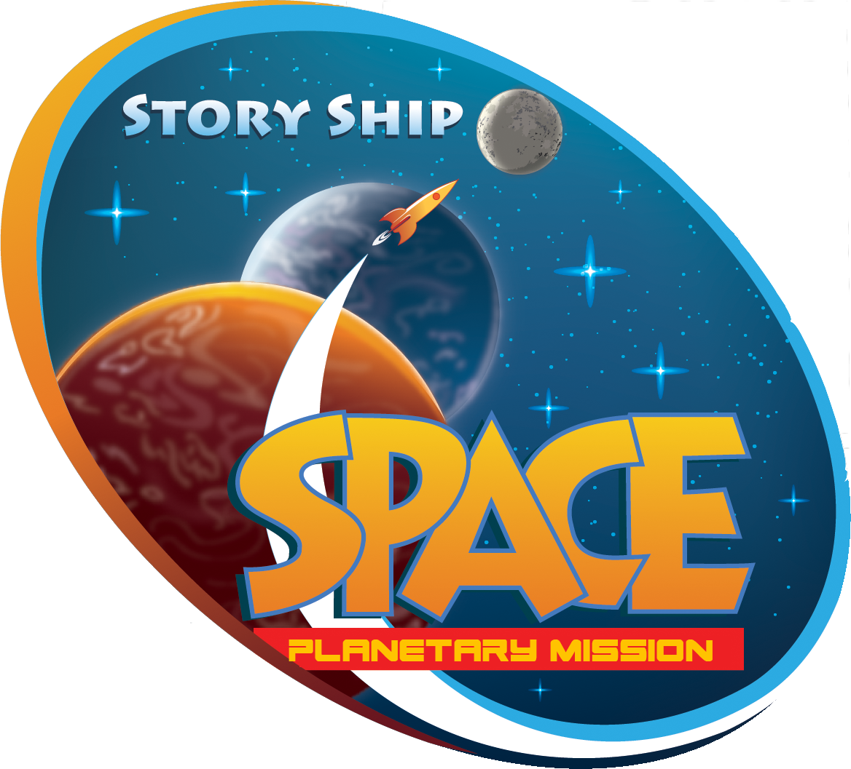
“Alien’s Alive”
An immersive
Theatrical Adventure
Study Guide for Pre-K- 5th Grades
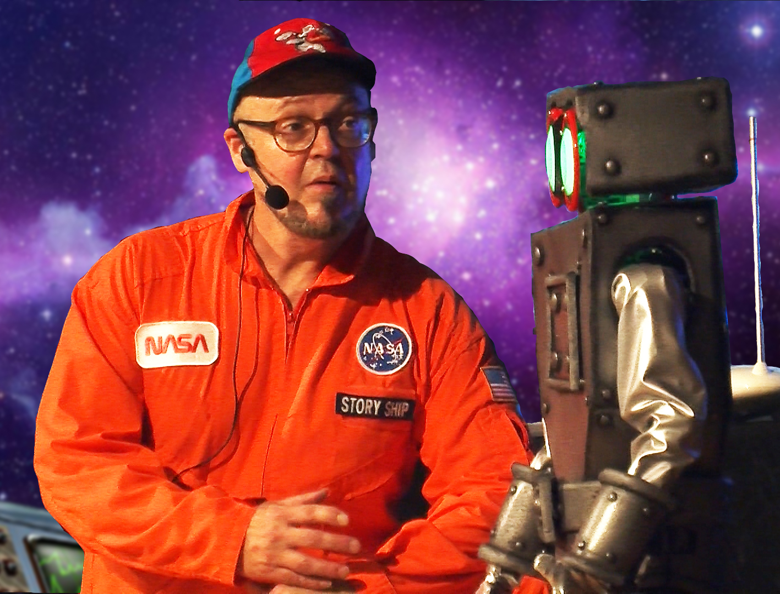
About the Program
While reporting live, The Story Ship’s science reporter, Sarah, is kidnapped by aliens and trapped on a space ship bound for the outer regions of our solar system. Audience volunteers must quickly form a rescue team and use magic, dance and music to get her back. The audience helps to unravel a celestial musical message. Each alien communication gives us clues as to the alien’s location and how to rescue Sarah. This show is highly interactive with audience participation every minute to two minutes with kids helping with magic tricks, singing, dancing, and navigating the rescue rocket through an interactive game.

Onstage, giant video animations and holographic images allow us to communicate and track Sarah’s amazing journey through our solar system. In school shows, audience members explore the relationship between music, math and space travel. Sarah is returned to earth safely. The show ends in a celebration as the aliens, audience and actors all dance to the melody the aliens sent us.

This fast-paced high energy show combines:
Interactive 3D Holograms
Animation projected on a large screen
Music played on a theremin
Gaming
Comedy Musical Theater

Program Objectives
Through listening to the story, interacting with the animated characters, and participating in the navigation of the Story Ship’s rocket, students learn facts about space and our solar system as outlined in the curriculum connections below. During the show, a number of students are asked to participate by assisting with solve math problems, playing musical instruments, dancing the alien dance, and performing magic tricks.
Pre-and post-performance discussions and activities are strongly suggested for students to get the most out of the performance experience.

Artist Bio
Sean Driscoll has thrilled audiences with performances of interactive animation, music, storytelling, theater, comedy and magic for thirty years. This unique combination makes their performances and workshops truly original. His company, The Story Ship, has artists performing regularly throughout the United States in theaters, schools, libraries, resorts, after school programs, and festival settings. They reach tens of thousands of children and adults each year through hundreds of residencies, workshops and performances. Mr. Driscoll has performed for groups up to 8,000 kids and performed over 5,000 shows.

Curriculum Standards Connections
Florida Curriculum Connections
KINDERGARTEN
SC.K.E.5.1
Explore the Law of Gravity by investigating how objects are pulled toward the ground unless something holds them up.
SC.K.E.5.3
Recognize that the Sun can only be seen in the daytime.
SC.K.E.5.5
Observe that things can be big and things can be small as seen from Earth.
SC.K.E.5.6
Observe that some objects are far away and some are nearby as seen from Earth.

MAFS.K.CC.1.3
Read and write numerals from 0 to 20. Represent a number of objects with a written numeral 0–20 (with 0 representing a count of no objects).

MAFS.K.G.1.1
Describe objects in the environment using names of shapes, and describe the relative positions of these objects using terms such as above, below, beside, in front of, behind, and next to.

MAFS.K.OA.1.2
Solve addition and subtraction word problems¹, and add and subtract within 10, e.g., by using objects or drawings to represent the problem (¹Students are not required to independently read the word problems.)

LAFS.K.RI.1.3
With prompting and support, describe the connection between two individuals, events, ideas, or pieces of information in a text.

FIRST GRADE
SC.1.E.5.1
Observe and discuss that there are more stars in the sky than anyone can easily count and that they are not scattered evenly in...
SC.1.E.5.2
Explore the Law of Gravity by demonstrating that Earth's gravity pulls any object on or near Earth toward it even though nothing...
SC.1.E.5.3
Investigate how magnifiers make things appear bigger and help people see things they could not see without them.

LAFS.1.RI.3.7
Use the illustrations and details in a text to describe its key ideas.

LAFS.1.RL.3.7
Use illustrations and details in a story to describe its characters, setting, or events.

MAFS.1.NBT.3.4
Add within 100, including adding a two-digit number and a one-digit number, and adding a two-digit number and a multiple of 10, using concrete models or drawings and strategies based on place value, properties of operations, and/or the relationship between addition and subtraction; relate the strategy to a written method and explain the reasoning used. Understand that in adding two-digit numbers, one adds tens and tens, ones and ones; and sometimes it is necessary to compose a ten.

DA.1.C.1.2
Repeat simple movements from verbal cueing.

DA.1.S.2.3
Perform simple movements on both sides of the body.

SECOND GRADE
SC.2.N.1.1
Raise questions about the natural world, investigate them in teams through free exploration and systematic observations.
SC.2.P.8.1
Observe and measure objects in terms of their properties, including size, shape, color, temperature, weight, texture, sinking or floating in water, and attraction and repulsion of magnets.

VA.2.C.1.2
Reflect on and discuss various possible meanings in works of art.

DA.2.C.1.2
Demonstrate listening, observing, and following skills while learning dance movements; and perform them with the teacher and alone.

VA.2.C.1.2
Reflect on and discuss various possible meanings in works of art.

MAFS.2.OA.1.1
Use addition and subtraction within 100 to solve one- and two-step word problems involving situations of adding to, taking from, putting together, taking apart, and comparing, with unknowns in all positions, e.g., by using drawings and equations with a symbol for the unknown number to represent the problem.

LAFS.2.RL.1.3
Describe how characters in a story respond to major events and challenges.

LAFS.2.RL.3.7
Use information gained from the illustrations and words in a print or digital text to demonstrate understanding of its characters, setting, or plot.

THIRD GRADE
SC.3.E.5.1
Explain that stars can be different; some are smaller, some are larger, and some appear brighter than others; all except the Sun are so far away that they look like points of light.

SC.3.E.5.2
Identify the Sun as a star that emits energy; some of it in the form of light.

SC.3.E.5.3
Recognize that the Sun appears large and bright because it is the closest star to Earth.

SC.3.E.5.4
Explore the Law of Gravity by demonstrating that gravity is a force that can be overcome.

DA.3.S.2.2
Learn and repeat movement using observation and listening skills.

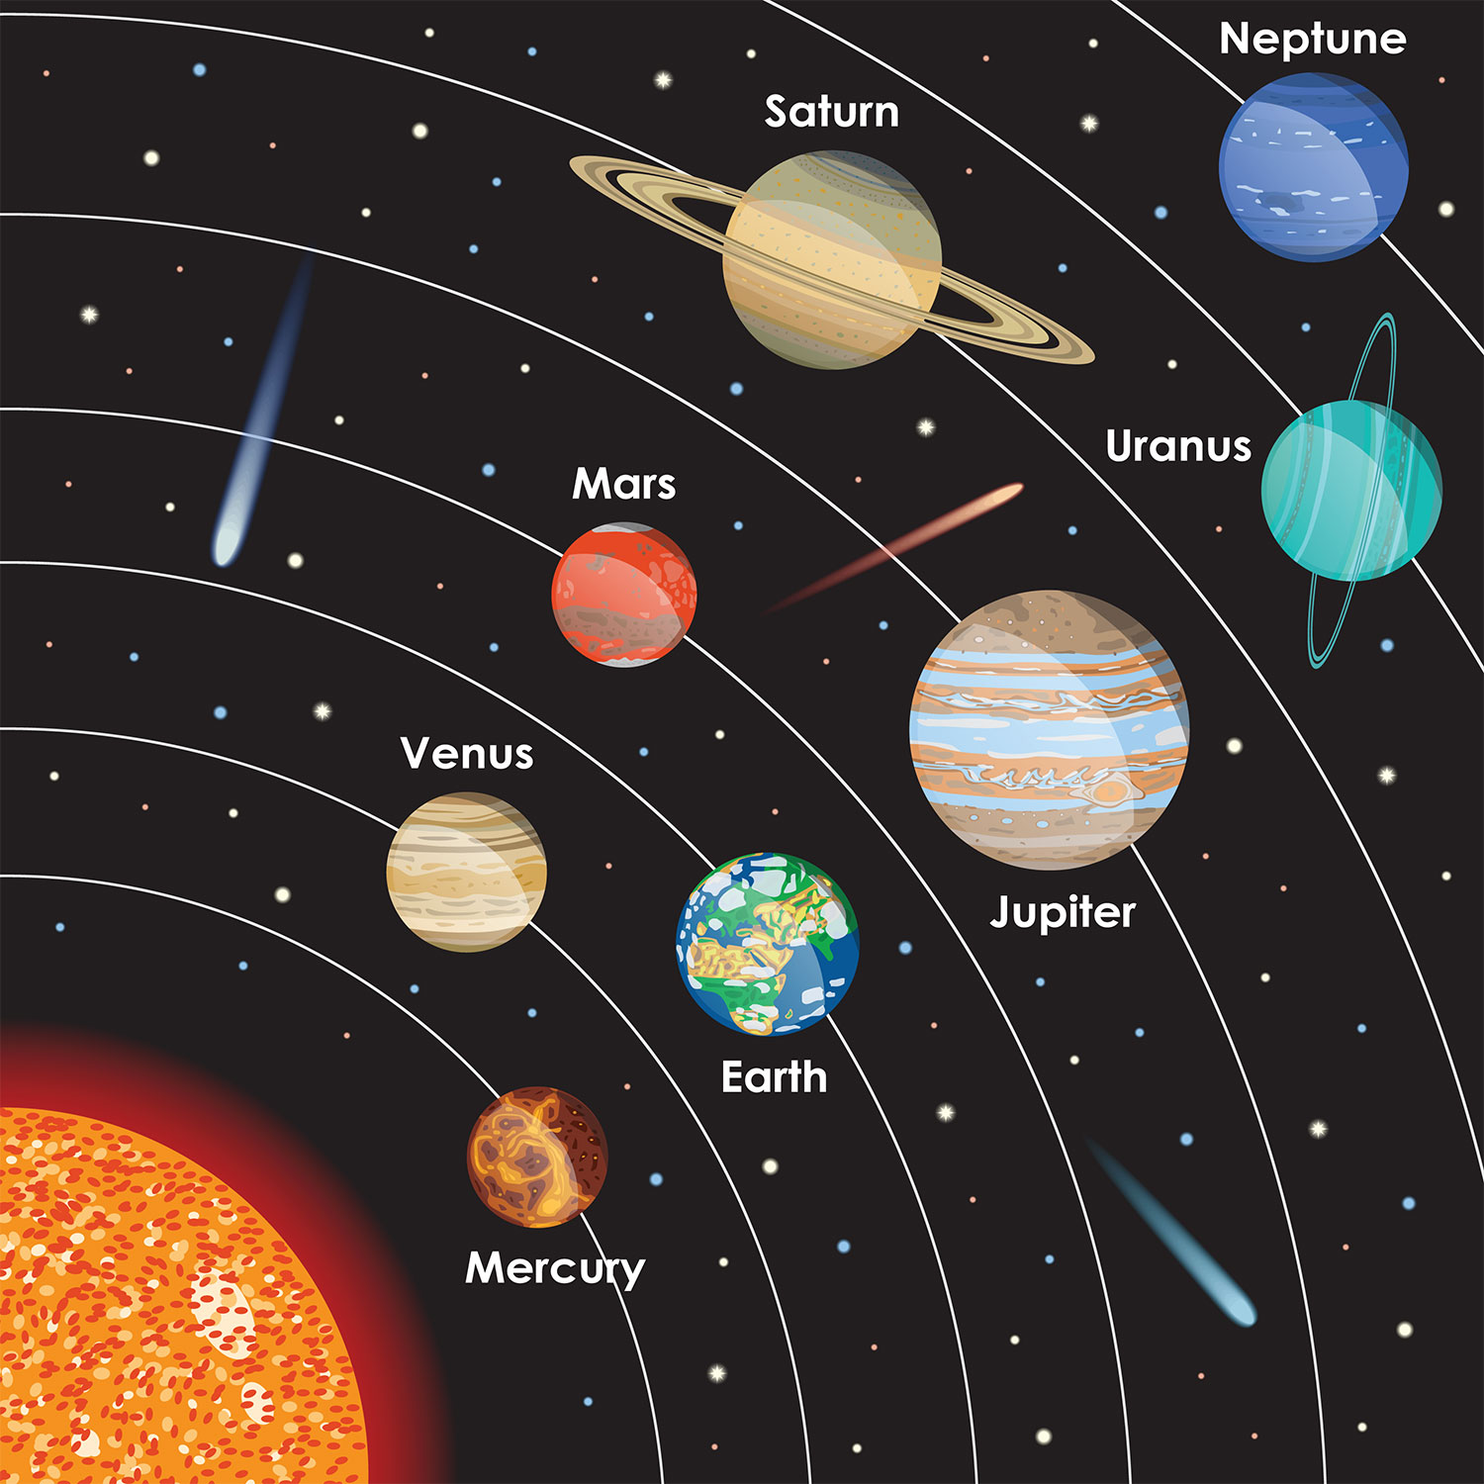

Pre-and Post-Performance Discussion Questions and Information
What are the parts of our solar system? Sun, Planets, Dwarf Planets, Asteroids, Meteorites, Comets

What are the names of the planets in our solar system? Mercury, Venus, Mars, Earth, Saturn, Jupiter, Uranus, Neptune

What is an eclipse? Passing of a shadow of the Sun, Moon or planet over another planet or object.

What is an electromagnetic wave and how are the used in our daily lives? How are they used in space exploration?
Electromagnetic waves are invisible energy waves that travel at the speed of light. These waves exist on spectrum and provide us with useful tools such as X-Rays to heal with, Radio Waves to communicate, Microwaves to cook with, GPS’s to navigate and much more.
Which planets are considered to be gas giants? Jupiter, Saturn, Neptune, Uranus
Name a physical characteristic of each planet?
Mercury – Has a solid core of iron. Shortly after the birth of the solar system, Mercury cooled rapidly making it’s surface wrinkled like the skin of an old man. Mercury is the closest planet to sun but not the hottest.
Venus – Is the hottest planet with a thick atmosphere that traps heat. It also has the most volcanoes of any planet.
Earth – Is the only planet known to have life with an abundance of water, plants and animals. It lies perfectly balanced from the sun with a moon and atmosphere that produces moderate temperatures allowing life to flourish.
Mars – is the red planet. The red comes from the presence of iron in the soil. Mars is home to the largest volcano in our solar system, Olympus Mons.
Jupiter – One of the gas giants, Jupiter is the largest planet. It has a giant storm three-times larger than the earth with the winds up to 425 mph.
Saturn – Is the planet with rings. It is made mostly of gas and spins so fast that the top and bottom flatten and the middle bulges. The rings of Saturn are made of dust and are very thin on the side. Sometimes the rings will disappear when the observer looks at the rings side-on! Saturn can float in water since gas is lighter than water!
Uranus – Spins on its side in retrograde motion or the opposite of the way most planets spin. It is known as the ice giant. Methane ice crystals give it a pale blue color. It has smaller lighter color rings than Saturn.
Neptune – is the blue planet furthest from the sun. It has the fastest winds of any planet 700 – 2000 miles per hour
What object lies at the center of our solar system? The sun is at the center of our solar system and occupies 98% mass. It’s strong gravitational pull keeps the planets, asteroids, comets and dwarf planets orbiting around it.
What is gravity? The force that attracts objects toward the center of the earth or one another.

General facts about the Solar System:
• The Sun’s gravity holds our planets and other solar system objects in place during their orbit.
• Each planet has their own orbit length and rotation. Their years depend how far they are from the sun and how fast they are traveling. Their days depend on how fast they spin.
So, each planet’s “year” and “day” is different.
• Jupiter is the biggest planet.
• Pluto is no longer considered a planet. For many years it was.
• The only planet in our system that has water and supports life is Earth. ¾ of the earth is cover in water.
. Mar’s does have an ice polar cap.
• About 500 years ago the astronomer Copernicus was the first to believe that every object in the universe revolved around the sun.
• Galileo created the first telescope 400 year ago allowing us our first glimpse into space. He was then able to prove Copernicus was both correct and incorrect. The objects in the solar system do revolve around the sun, but the stars and galaxies of deep space do not.

Pre- or post- Performance Activity Suggestions
Art:
- Create hats for each of solar system parts to be used in the cross-curriculum activities below.
- Illustrate a story about space travel written by the students. (See Projects Below)

Language Arts:
- Create A Space Adventure Book- Where should the Story Ship go next? What adventure should Captain Starfield and the Story Ship rocket go on? Write a space exploration story using our cast of characters. Use our online story book creation study guide to create your story. Have the kids illustrate the story and create a book.
- Solar System Parts Paragraphs – Have students write a paragraph describing each solar system part.

Science:
1. Make a living solar system out of kids and use Mar’s “The Planet’s Go Marching” to have the students move demonstrate the spinning and orbiting motion of the planets.
- Print out large images of each part of the solar system and have the kids create hats for each planet, the sun, moons and asteroids and comets etc.
- Download the “The Planet’s Go Marching Song” lyrics from the Story Ship’s Website and play the song from the web page audio file.
- Turn out the lights and use a camping lantern as the sun.
- Make sure you have plenty of space in the room for kids to move. A gym or multipurpose room is best. Mark each object’s motion on the floor using color coded tape.
- Set each student into motion spinning and orbiting around their objects in a reasonable path.
- Stop the song and point out a lunar and solar eclipse as the student pass in front of each other blocking the lantern’s light. Ask students if they notice any other planets experiencing the same events.
- Have each student present a little statement about the most unusual characteristics of their solar system object.
2. Go on a journey through the solar system via National Geographic! https://kids.nationalgeographic.com/search?q=solar%20system&location=srp&type=manual
3. Explore the science of sound and energy waves by conducting the following experiments with your students.
Observe sound energy being transfered by conducting the following experiments:
Pan and Peas Vibrations Experiment
Sound Propagation Through Water Glasses
Seven Ways to See Sound

4. Easy experiments to teach young kids gravity
Paper clips and magnets
Penny Drop

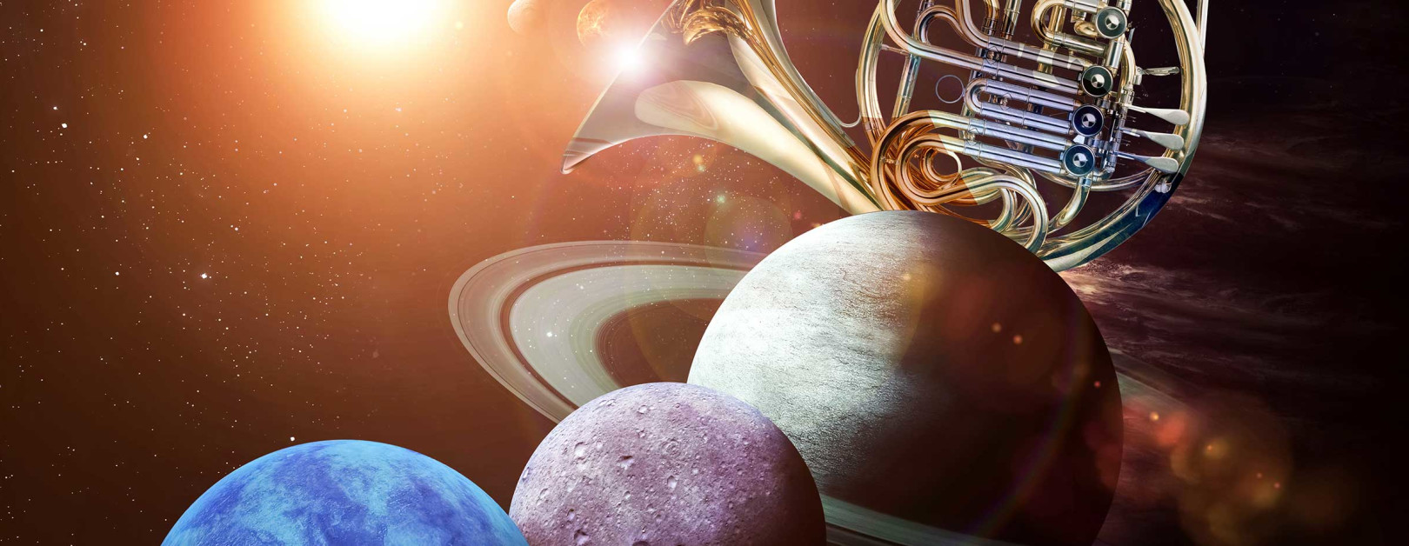
Music & Art:
- Gustav Holtz – Planets Symphonic Adventure
  - Play each one of the movements of Holtz’s symphonic work, “The Planets.”
  - Discuss the major traits of the planets listed below.
  - Play each movement and have the students raise their hands as the music is playing when they hear something in the music that symbolizes the traits of each planet.
  - Ask kids to illustrate what they see in their mind’s eye as they listen to each planet.
- High or Low, Loud or Soft – Play a game to identify high and low pitches and loud and soft pitches. Use a xylophone or piano to play pitches while the kids are blindfolded and ask them to raise their hands for higher or lower or louder or softer notes. This is a great opportunity to teach notation of volume in musical scores.

Coloring Pages

http://www.supercoloring.com/coloring-pages/space-astronomy/planets

